Martin Villasenor

ECG 603

LAB4 SYS/BIOS BLINK LED

Configuring and building empty.cfg without modifying main.c or cfg file.

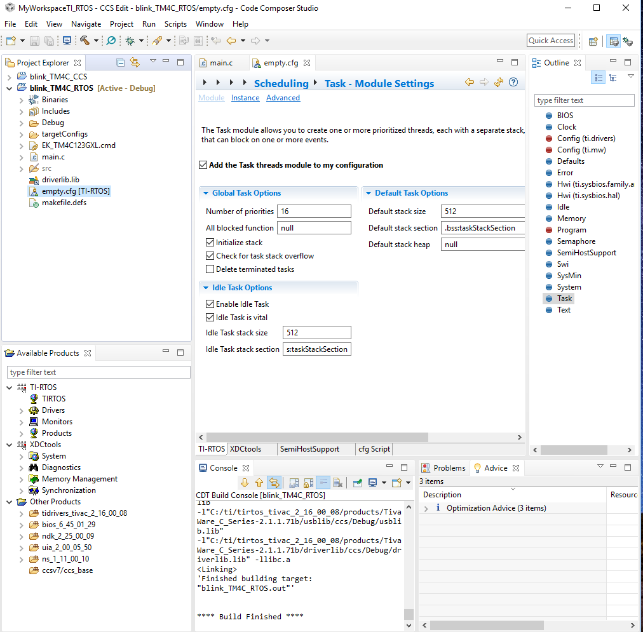

Registering ledToggle() as Idle Thread. Function added on configuration box for the idle module. The cfg script shows the new added function “ledToggle”.

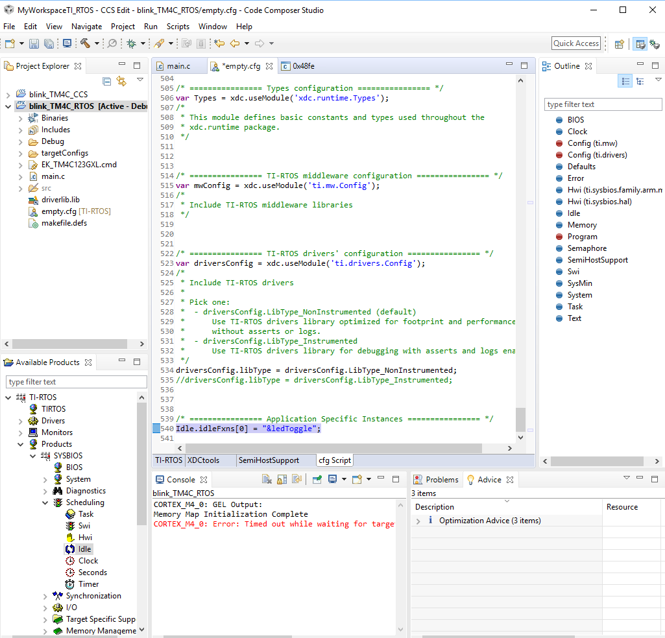

After setting the loggingSetup functionality using the Unified Instrumentation Architecture. Figure below shows filtered messages from live session of RTOS analyzer using the logging function Log_info1() added to ledToggle().

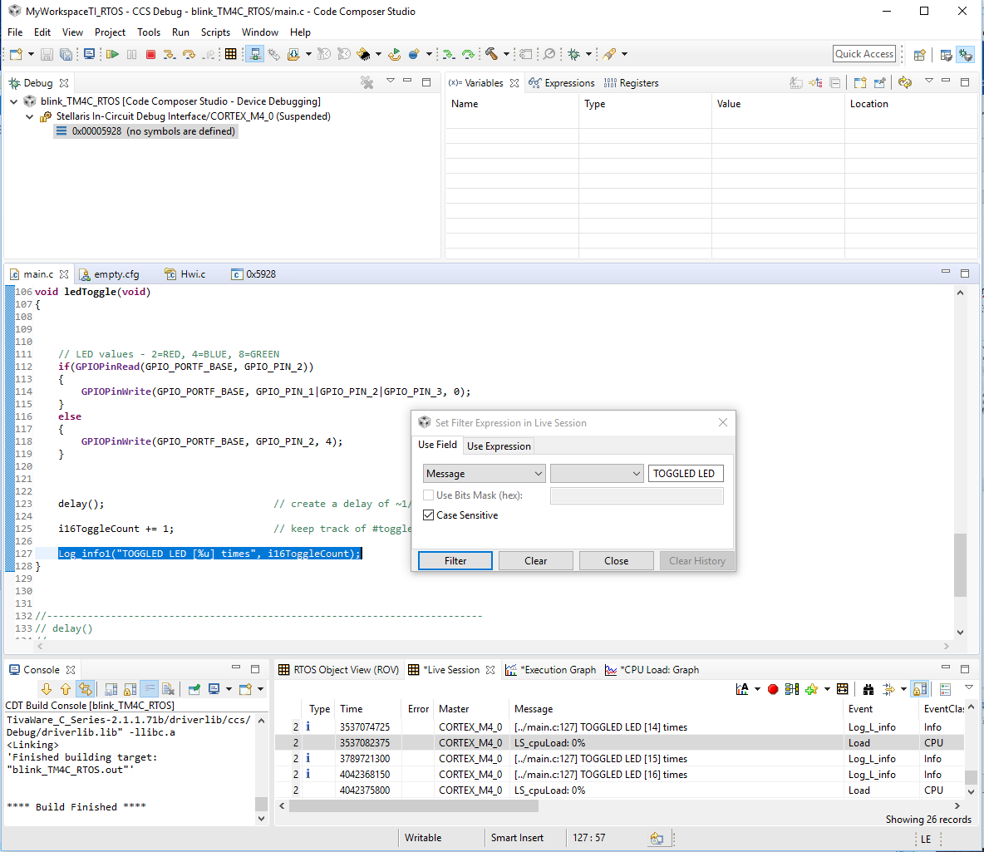

LAB5 USING HWI

Configuring HWI module to run the ledToggle task when timer2 interrupt occurs.

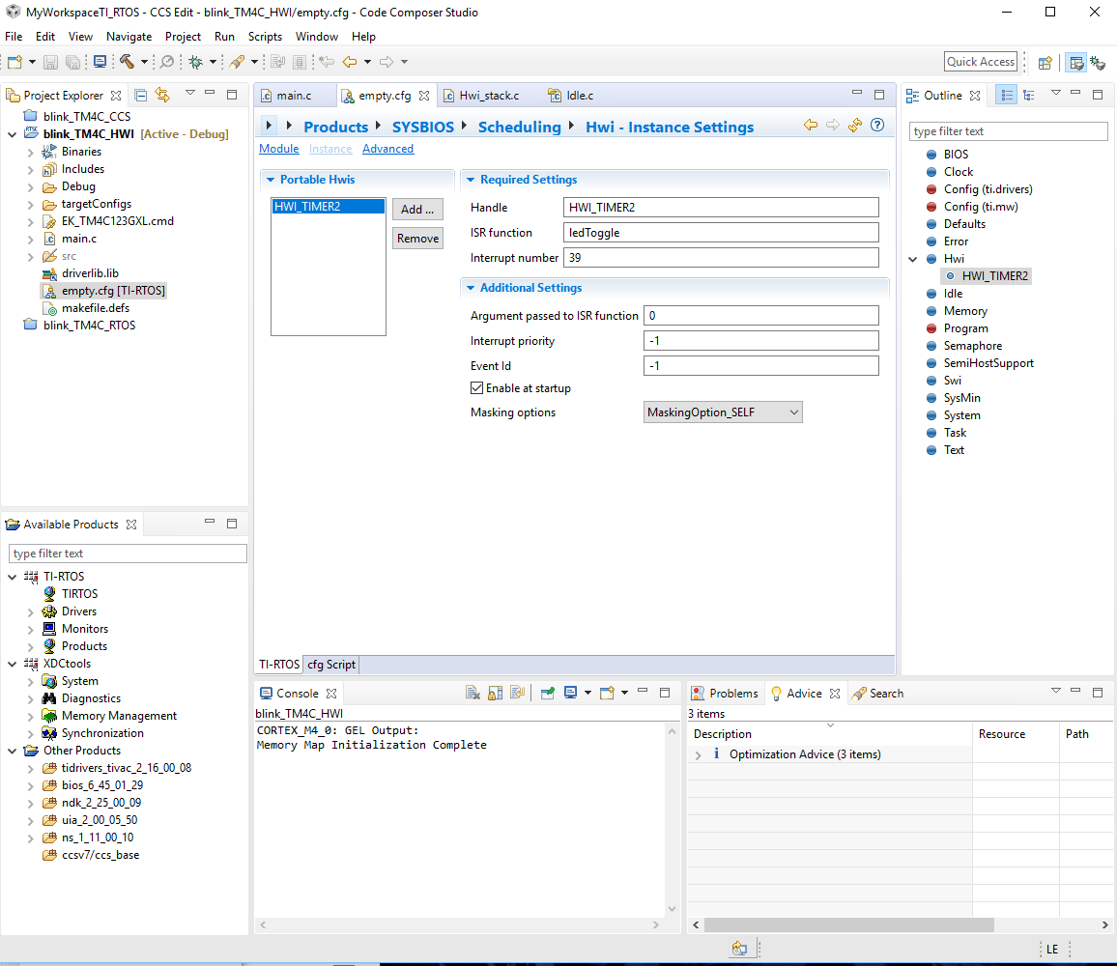

Removing delay() since RTOS will take care of task switching and as a consequence it will call the timer interrupt causing the toggle function to be called in a 500 ms interval time.

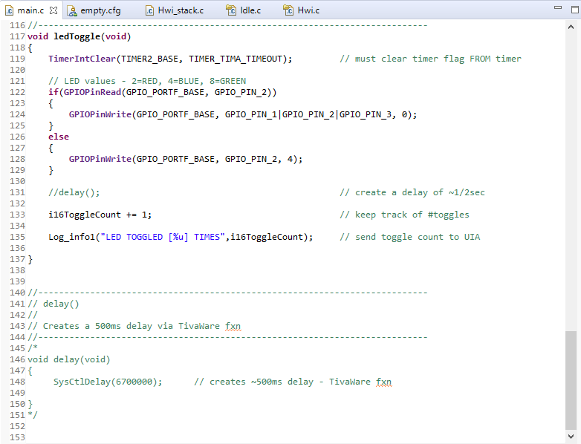

Using RTOS analyzer tool to examine live session results after running code for a few seconds showing up to 28 LED toggles.

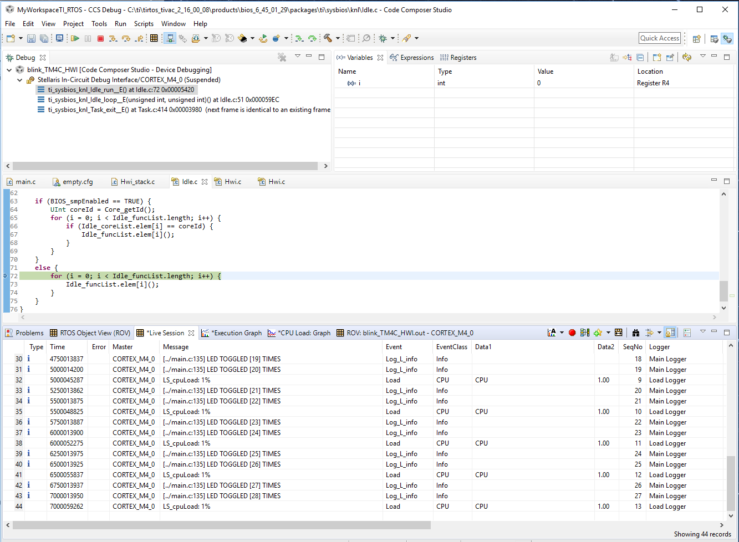

LAB6 Blink LED using SWI

Modified main.c with new function called by Swi.

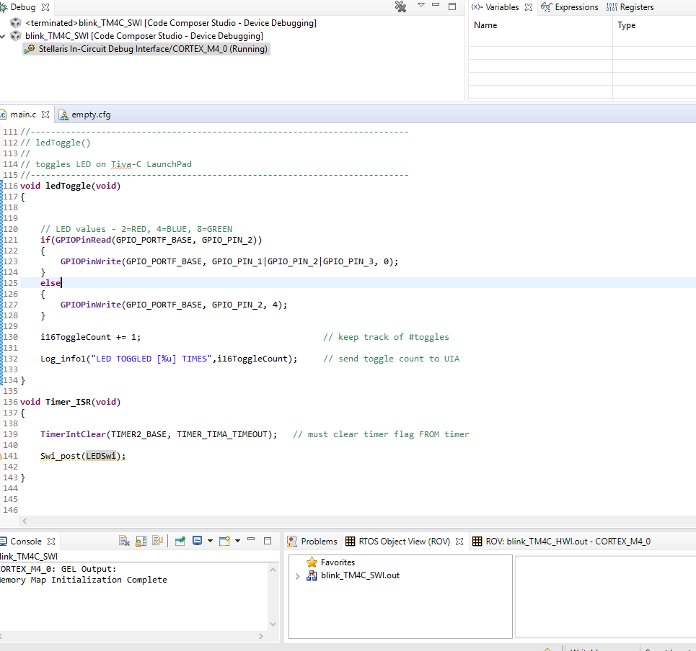

Swi Configuration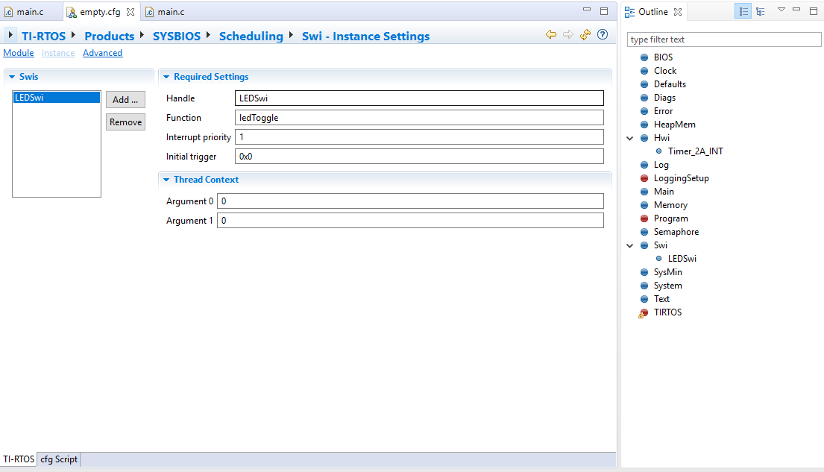

Hwi configuration

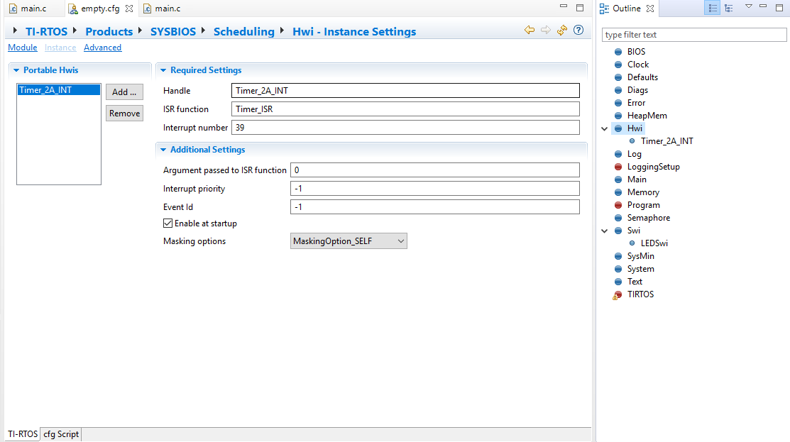

RTOS analyzer after a 10 second time execution.

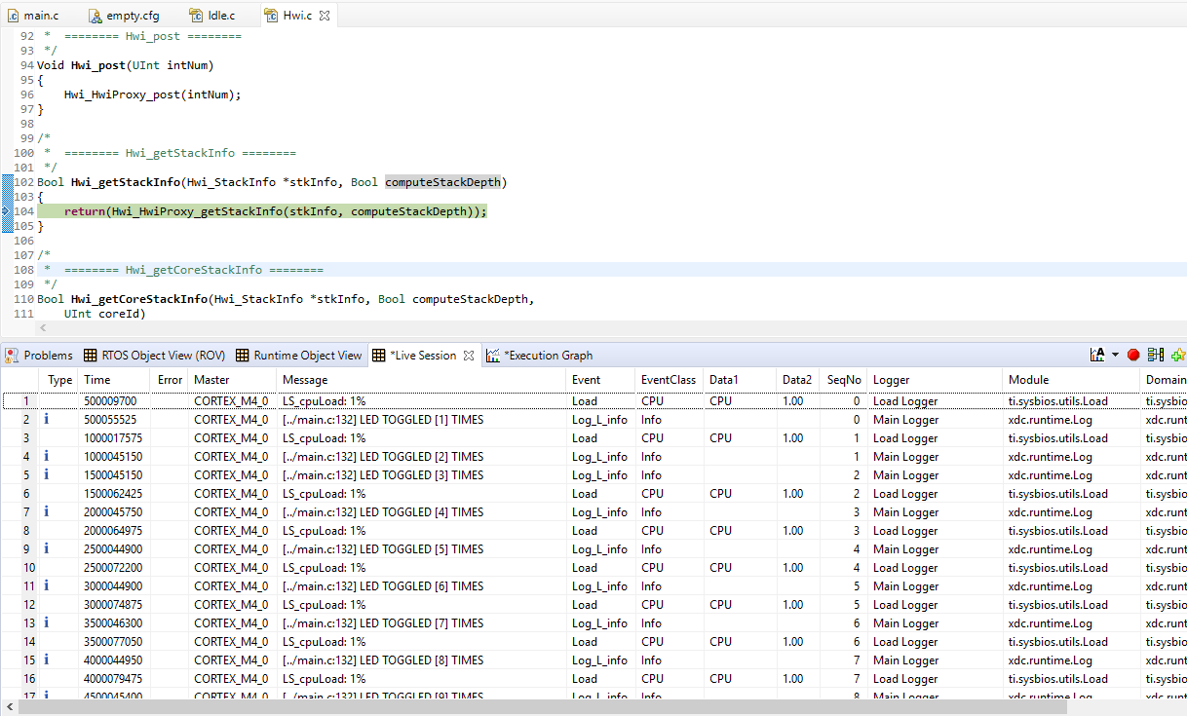

Execution graph

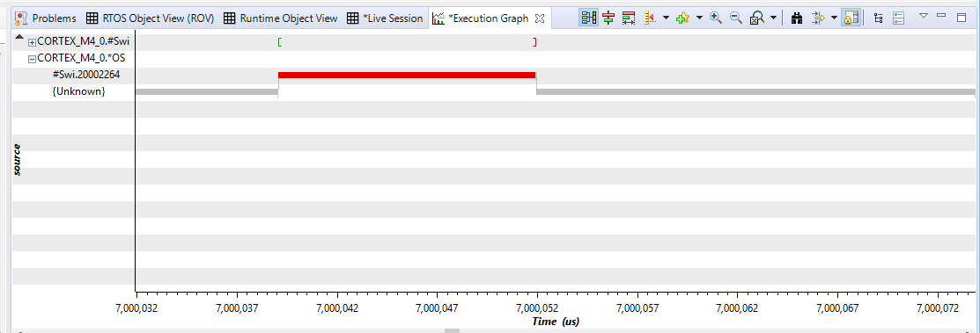

LED toggle time 13 useconds.

